**Theory Activity No. 1**

Name: Yadnesh Naik

Prn: 202401120056

Roll no. : CS8-38

Batch:Cs82

**20 Problem statements:**

|  |  |
| --- | --- |
| 1 | Find the total number of missing values in each column. |

|  |  |
| --- | --- |
| 2 | Drop rows with any missing values. |

|  |  |
| --- | --- |
| 3 | Find the unique part_of_speech values. |

|  |  |
| --- | --- |
| 4 | Find the most frequent part_of_speech. |

|  |  |
| --- | --- |
| 5 | Find the number of lemmas associated with each part_of_speech. |

|  |  |
| --- | --- |
| 6 | Find the top 10 most common lemmas. |

|  |  |
| --- | --- |
| 7 | Find how many lemmas have more than 3 synonyms. |

|  |  |
| --- | --- |
| 8 | Find the lemma with the highest number of synonyms. |

|  |  |
| --- | --- |
| 9 | Calculate the average number of synonyms per lemma. |

|  |  |
| --- | --- |
| 10 | List all lemmas that have only one synonym. |

|  |  |
| --- | --- |
| 11 | Find all synonyms containing the word "caliber". |

|  |  |
| --- | --- |
| 12 | Replace all hyphens "-" in lemma and synonyms with spaces. |

|  |  |
| --- | --- |
| 13 | Find all lemmas that are adjectives. |

|  |  |
| --- | --- |
| 14 | Find the number of unique lemmas. |

|  |  |
| --- | --- |
| 15 | Find the number of lemmas whose synonyms list contains duplicates. |

|  |  |
| --- | --- |
| 16 | Create a new column num_synonyms that counts synonyms for each lemma. |

|  |  |
| --- | --- |
| 17 | Filter lemmas whose synonyms include themselves. |

|  |  |
| --- | --- |
| 18 | Find lemmas with the shortest synonym list (excluding missing ones). |

|  |  |
| --- | --- |
| 19 | Find lemmas where synonyms field includes a synonym with a number (e.g., "22", "38"). |

|  |  |
| --- | --- |
| 20 | Find average synonym count per part_of_speech. |
|  |  |

|  |  |
| --- | --- |
| **CODE:** |  |

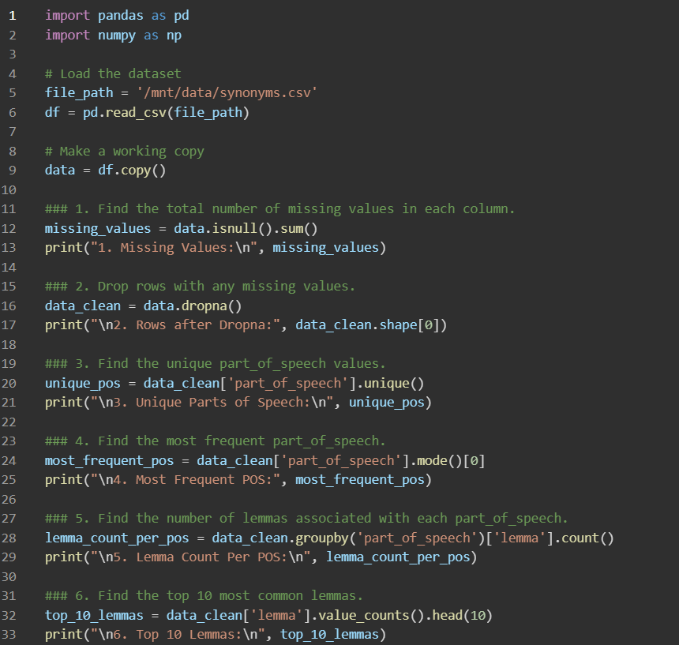

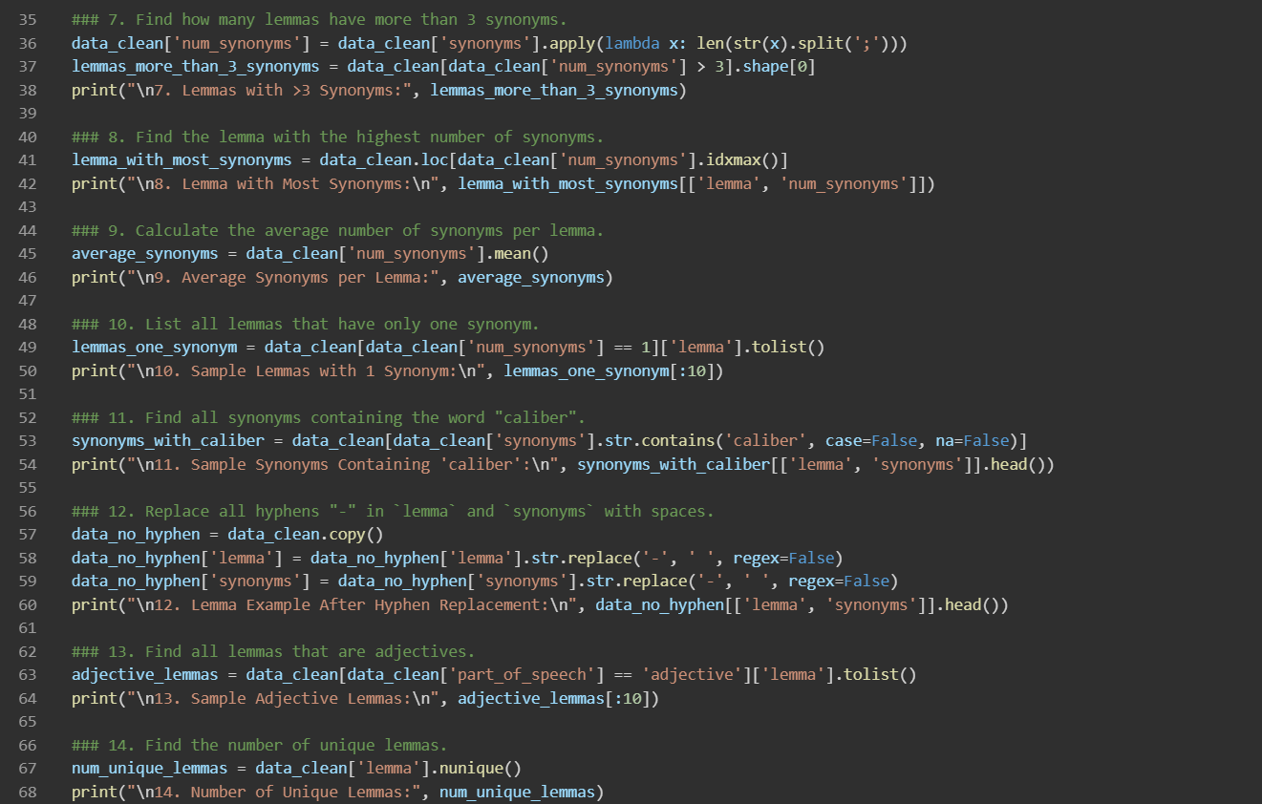

**OUTPUT:**

**1. Missing Values**

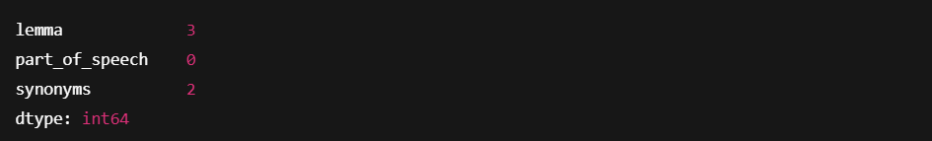

**2. Rows after Dropna**



**3. Unique Parts of Speech**



**4. Most Frequent Part of Speech**



**5. Lemma Count Per Part of Speech**

**6. Top 10 Lemmas**

**7. Number of Lemmas with >3 Synonyms**



**8. Lemma with Most Synonyms**



**9. Average Synonyms per Lemma**



**10. Sample Lemmas with Exactly 1 Synonym**



**11. Sample Synonyms Containing 'Caliber'**

**12. Hyphen Replaced in Lemma and Synonyms (Sample)**

**13. Sample Adjective Lemmas**

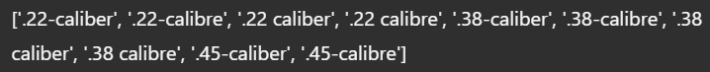

**14. Number of Unique Lemmas**



**15. Number of Lemmas with Duplicate Synonyms**



**16. Does 'num_synonyms' Column Exist?**



**17. Sample Lemmas with Themselves in Their Synonyms**

**18. Sample Lemmas with Fewest Synonyms**



**19. Sample Lemmas Whose Synonyms Contain Numbers**

**20. Average Synonym Count Per Part of Speech**

